

**Black Friday Sales Prediction**

***Wireframe Documentation***

**Data Visualization using Power BI**

During Exploratory Data Analysis, Following insights about the Train Data and Test Data has been found which are given below:

1. **Sum of Actual Purchase by Age, Gender, Occupation and City Category in Train Dataset**

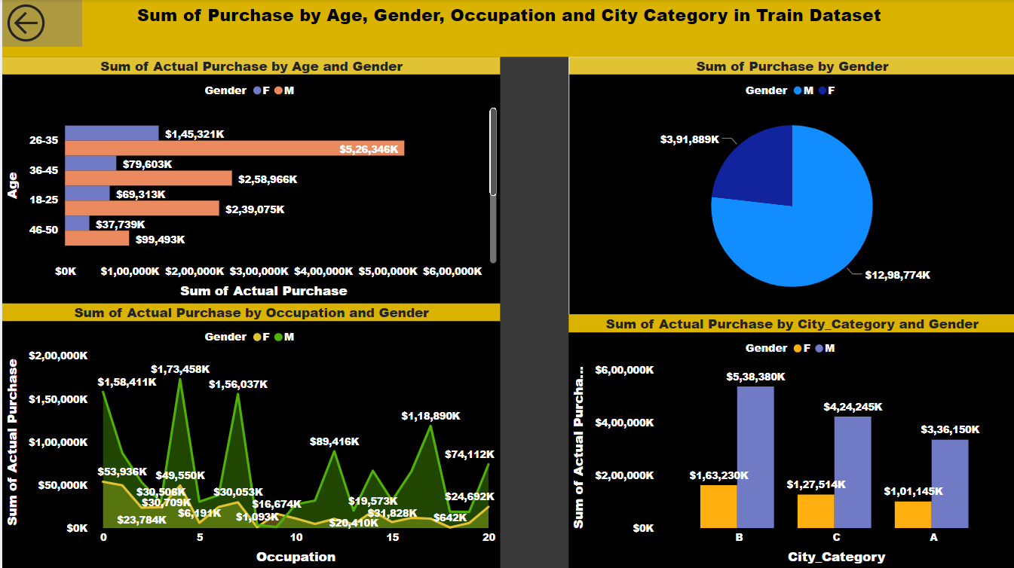

From the Above Insight, following data can be seen:

1. Sum of actual purchase is highest in age group between 26-35 at $5,26,346k for Male and $1,45,321k for Female.
2. Sum of actual purchase is $12,98,774k for male and $3,91,889k for female.
3. Sum of actual purchase is highest in occupation 5 at $1,73,458k for male and $53,936k for female at 0 occupation.
4. Sum of actual purchase is highest in City Category B at $5,38,380k for Male and $1,63,230k for female.
5. **Sum of Actual Purchase by Product Category 1,2 &3 in Train Dataset**

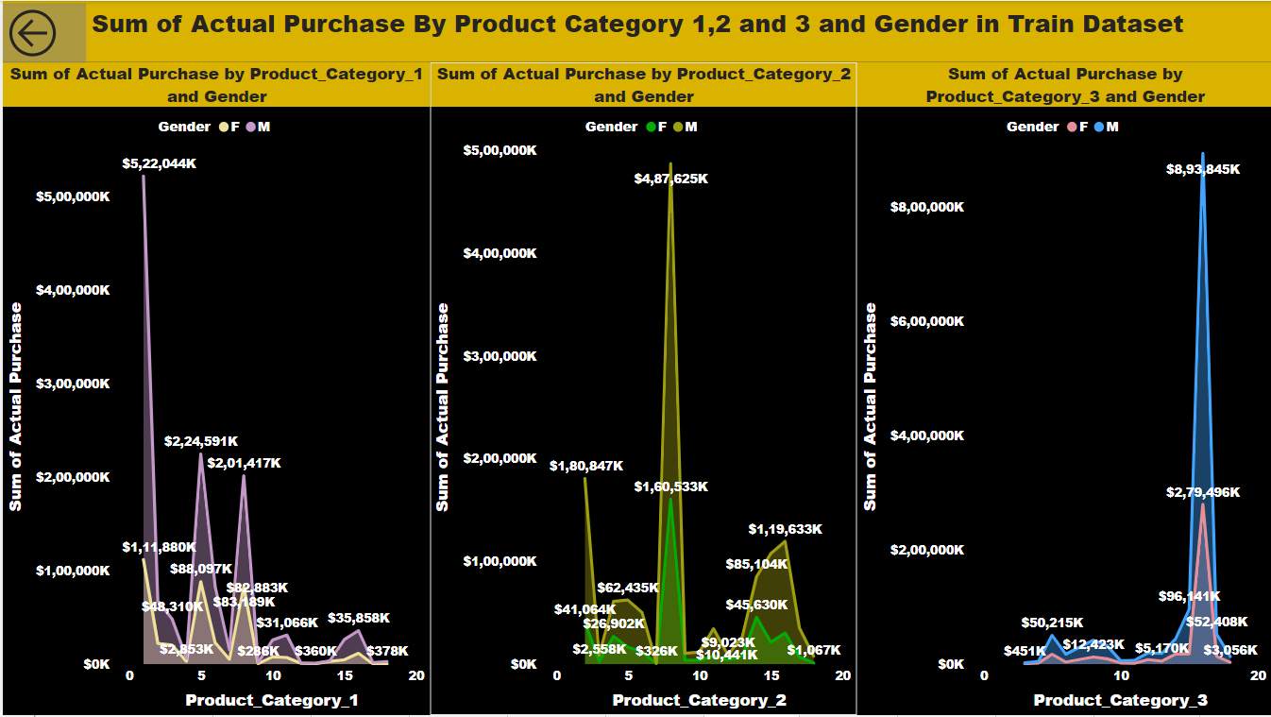

From the Above Insight, following data can be seen:

1. Sum of Actual Purchase is highest in Product category 1 at $5,22,044k for Male in 1 and $2,24,591k for female in 5.
2. Sum of Actual Purchase is highest in Product category 2 at $4,87,625k for Male in 8 and $1,80,847k for female in 2.
3. Sum of Actual Purchase is highest in Product category 3 at $8,93,845k for Male in 16 and $2,79,496k for female in 16.
4. **Dashboard for Random Forest Regressor**

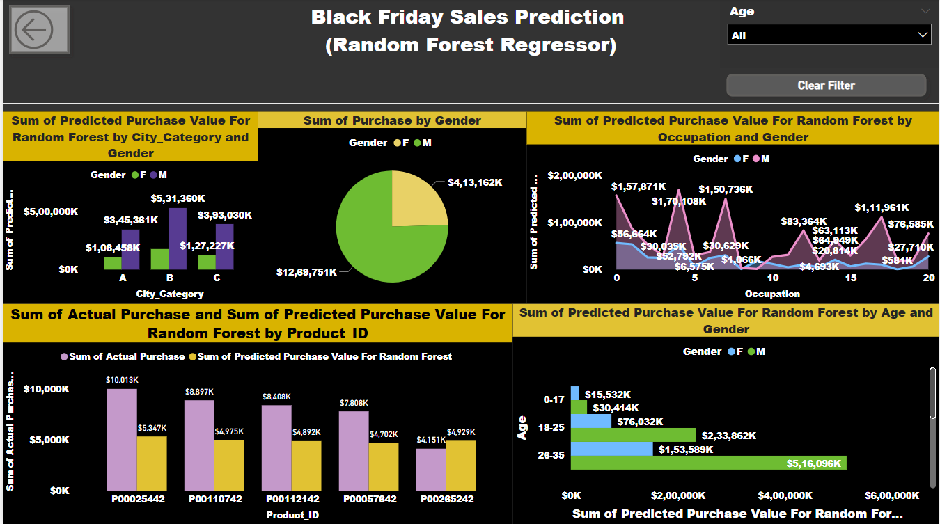

From the Above Insight, following data can be seen:

1. Sum of Predicted Purchase value for Random Forest is highest with $5,31,360k for Male and $1,77,477k in city category B .
2. Sum of purchase by gender for Random forest is $12,69,751K for Male and $4,13,162k for female.
3. Sum of Predicted Purchase value for Random forest is highest with $1,57,871k for Male and $56,664k for female in occupation category 0.
4. Sum of actual purchase is highest with $10,013k and Sum of predicted purchase value is highest with $5,347k for Random forest in product id P00025442.
5. Sum of Predicted purchase value for Random Forest is highest with $5,16,096k for Male and $1,53,589k for female in the age group 26-35.
6. **Dashboard for XGBoost Regressor**

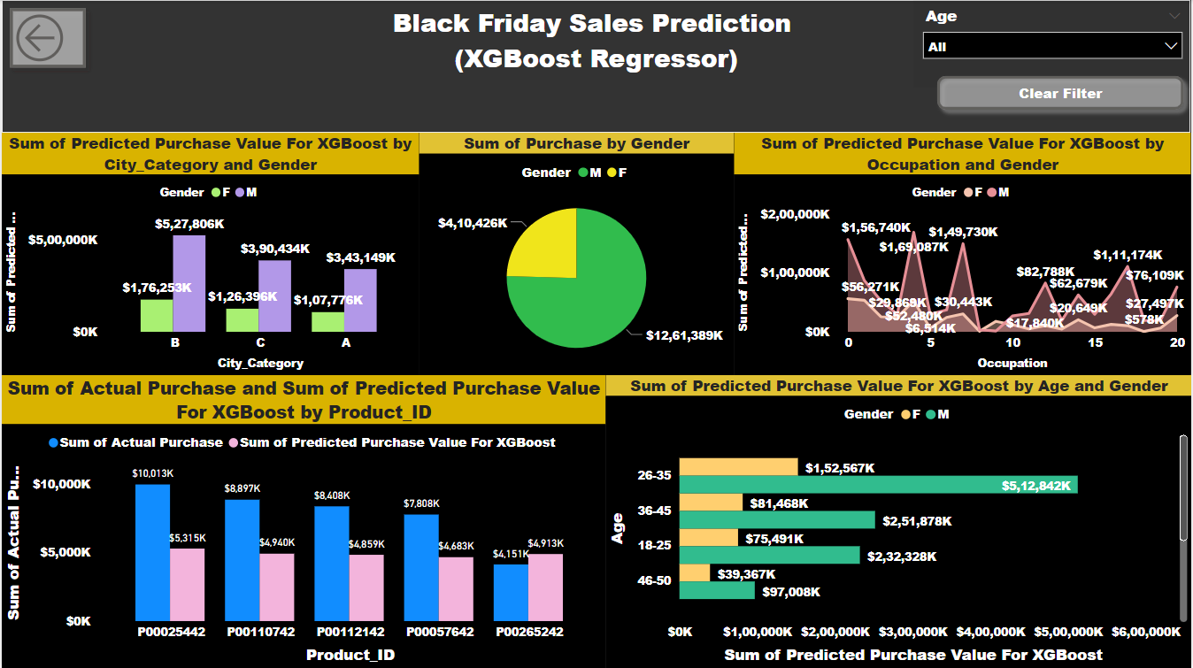

From the Above Insight, following data can be seen:

1. Sum of Predicted Purchase value for Random Forest is highest with $5,27,806k for Male and $1,76,253k in city category B .
2. Sum of purchase by gender for Random forest is $12,61,389K for Male and $4,10,426k for female.
3. Sum of Predicted Purchase value for Random forest is highest with $1,56,740k for Male and $56,271k for female in occupation category 0.
4. Sum of actual purchase is highest with $10,013k and Sum of predicted purchase value is highest with $5,315k for Random forest in product id P00025442.
5. Sum of Predicted purchase value for Random Forest is highest with $5,12,842k for Male and $1,52,567k for female in the age group 26-35.

(5) **Dashboard for Test Dataset**

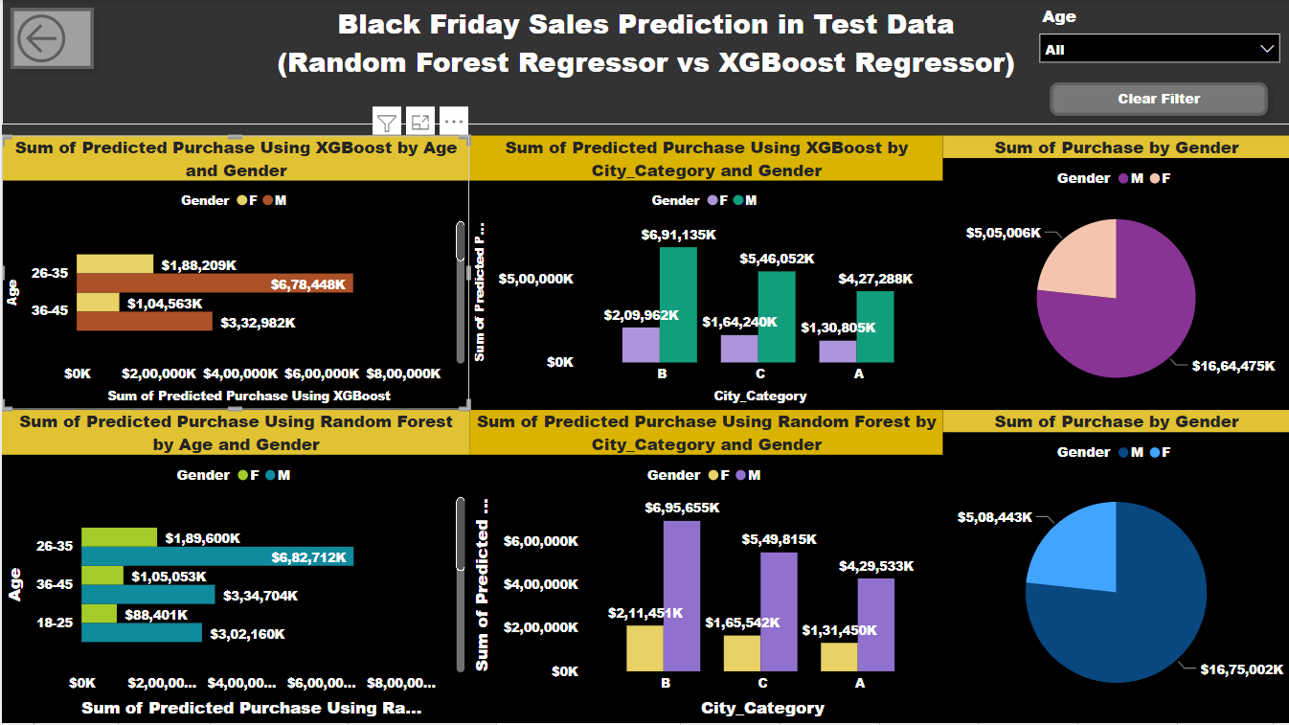

From the Above Insight, following data can be seen:

1. Sum of Predicted Purchase using XGBoost regressor for test dataset is highest in the age group 26-35 at $6,78,448k for Male and $1,88,209k for Female.
2. Sum of predicted purchase using XGBoost regressor for test dataset is highest in the city category B at $6,91,135k for Male and $2,09,962k for female.
3. Sum of predicted purchase using XGBoost regressor for test dataset is $16,64,475k for Male and $5,05,006k for female.
4. Sum of Predicted Purchase using Random forest regressor for test dataset is highest in the age group 26-35 at $6,82,712k for Male and $1,89,600k for Female.
5. Sum of predicted purchase using Random forest regressor for test dataset is highest in the city category B at $6,95,655k for Male and $2,11,451k for female.
6. Sum of predicted purchase using Random forest regressor for test dataset is $16,75,002k for Male and $5,08,443k for female.
7. **Sum of Predicted Purchase by Product Category 1,2 and 3 in Train Dataset for Random Forest**

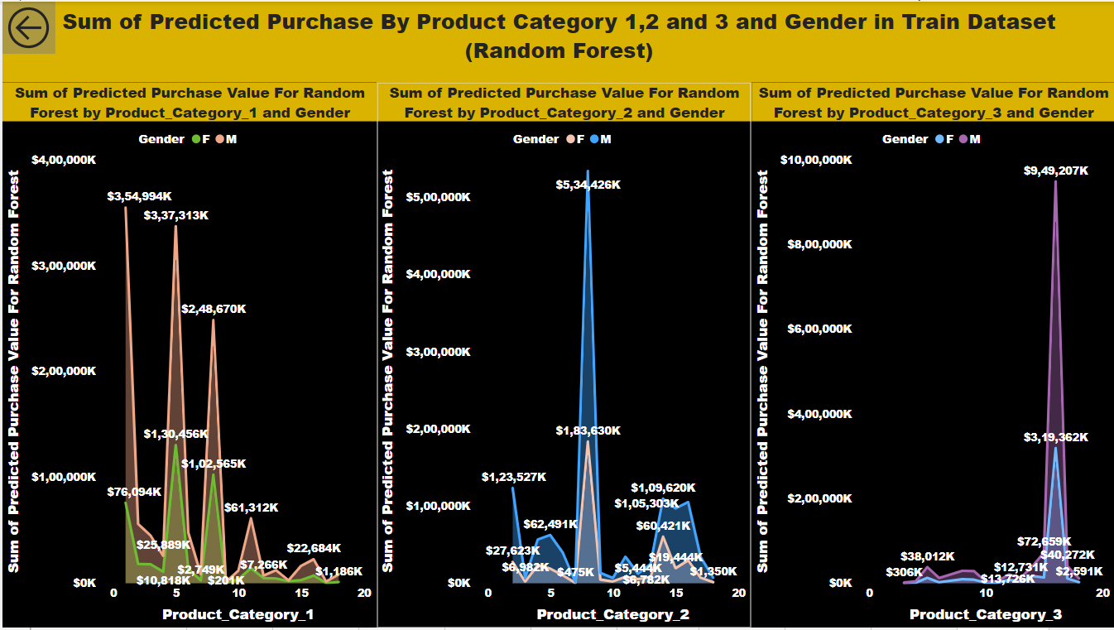

From the Above Insight, following data can be seen:

1. Sum of Predicted Purchase is highest in Product category 1 at $3,54,994k for Male in 1 and $1,30,456k for female in 5.
2. Sum of Predicted Purchase is highest in Product category 2 at $5,34,426k for Male in 8 and $1,83,630k for female in 8.
3. Sum of Predicted Purchase is highest in Product category 3 at $9,49,207k for Male in 16 and $3,19,362k for female in 16.
4. **Sum of Predicted Purchase by Product Category 1,2 and 3 in Train Dataset for XGBoost**

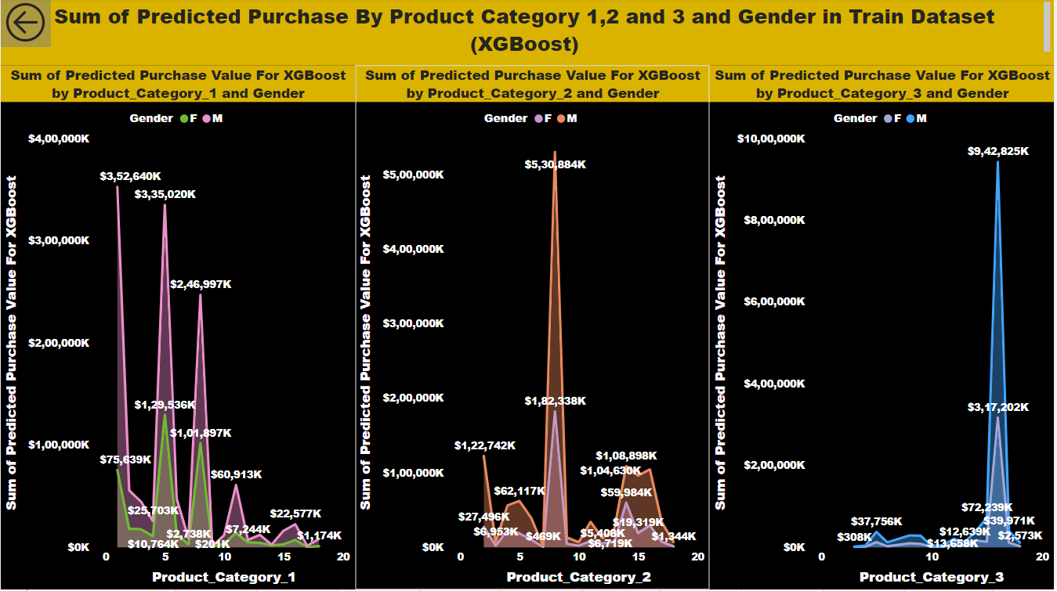

From the Above Insight, following data can be seen:

1. Sum of Predicted Purchase is highest in Product category 1 at $3,52,640k for Male in 1 and $1,29,536k for female in 5.
2. Sum of Predicted Purchase is highest in Product category 2 at $5,30,884k for Male in 8 and $1,82,338k for female in 8.
3. Sum of Predicted Purchase is highest in Product category 3 at $9,42,825k for Male in 16 and $3,17,202k for female in 16.
4. **Sum of Predicted Purchase by Product Category 1,2 and 3 in Test Dataset for Random forest**

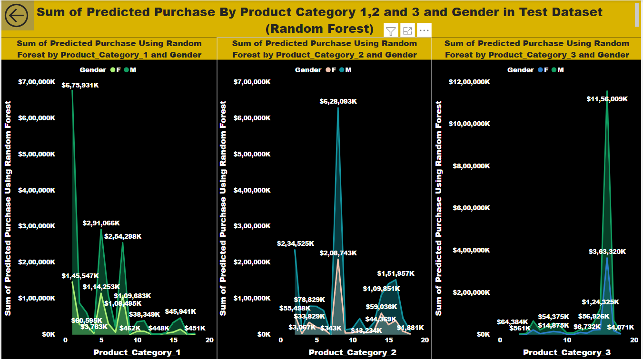

From the Above Insight, following data can be seen:

1. Sum of Predicted Purchase is highest in Product category 1 at $6,75,931k for Male in 1 and $1,45,547k for female in 1.
2. Sum of Predicted Purchase is highest in Product category 2 at $6,28,093k for Male in 8 and $2,08,743k for female in 8.
3. Sum of Predicted Purchase is highest in Product category 3 at $11,56,009k for Male in 16 and $3,63,320k for female in 16.
4. **Sum of Predicted Purchase by Product Category 1,2 and 3 in Test Dataset for XGBoost**

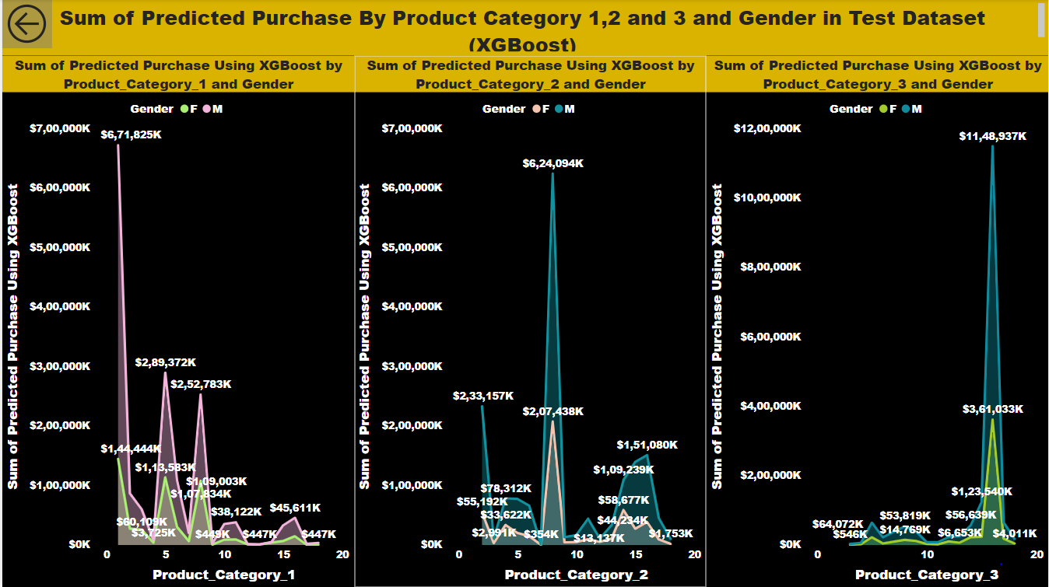

From the Above Insight, following data can be seen:

1. Sum of Predicted Purchase is highest in Product category 1 at $6,71,825k for Male in 1 and $1,44,444k for female in 1.
2. Sum of Predicted Purchase is highest in Product category 2 at $6,24,094k for Male in 8 and $2,07,438k for female in 8.
3. Sum of Predicted Purchase is highest in Product category 3 at $11,48,937k for Male in 16 and $3,61,033k for female in 16.

(10) **Sum of Predicted Purchase Using Random Forest and XGBoost for Product id in Test Dataset**

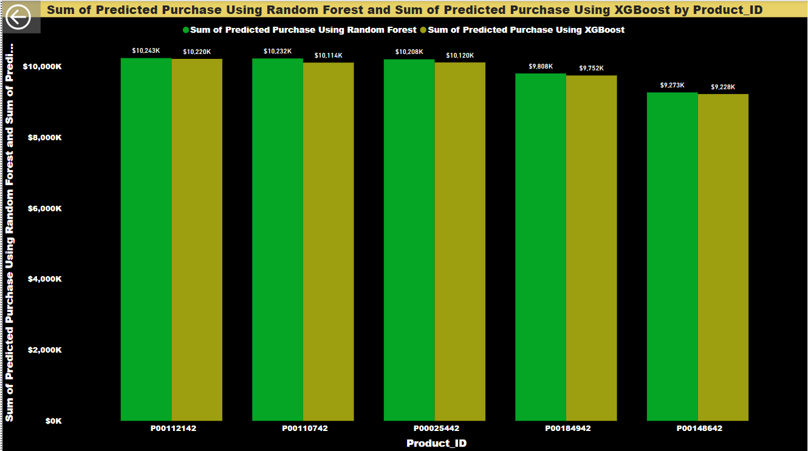

From the Above Insight, following data can be seen:

1. Sum of Predicted purchase using Random forest regressor in Test Data is highest with $10,243k in Product id P00112142.
2. Sum of Predicted purchase using XGBoost regressor in Test Data is highest with $10,220k in Product id P00112142.